Thermal energy of heating solids and incompressible liquids:
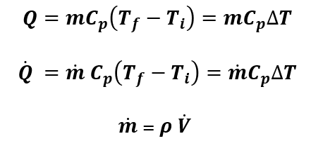
For water C=4.18 kJ/kg.K = 1 Btu/lb.R
Combustion Efficiency
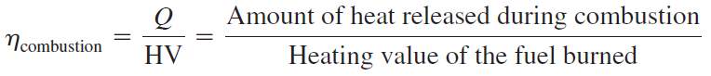
Approximate heating value of fuels:
Fuel | Quantity | Average Energy Content
Coal | One pound | 10,000 Btu (10.5×10⁶ J)
Diesel | One gallon | 139,000 Btu (146.6×10⁶ J)
Gasoline | One gallon | 124,000 Btu (130.8×10⁶ J)
Fuel Oil (Home Heating Oil) | One gallon | 139,000 Btu (146.6×10⁶ J)
Natural Gas | One cubic foot | 1,000 Btu (1.05×10⁶ J)
Wood | One cord (128 ft³)  (4×4×8 feet pile of wood stacked neatly) | 20,000,000 Btu (21.1×10⁹ J)

Overall efficiency of a power plant:
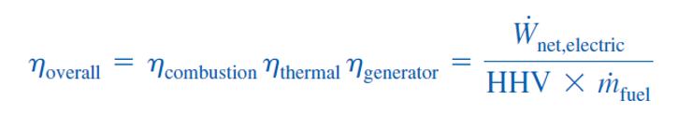
Energy Efficiency Ratio (EER) and Seasonal Energy Efficiency Ratio (SEER):
Emission of fossil fuels:
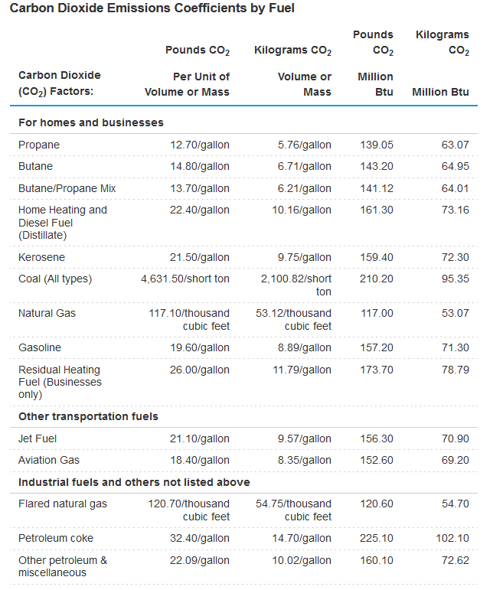
Human Development Index:
$$HDI= \frac{GDPI+LEI+EI}{3}$$
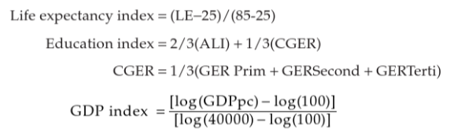
Exponential and logistic growth models:

Capital Recovery Factor and Annual Capital Cost:
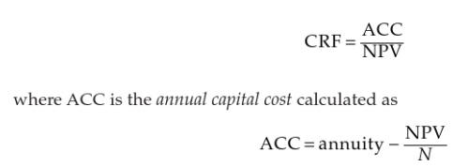
Present, future and uniform end of terms (e.g., annual) relation:

$F = A \left[\frac{{\left(1 + i\right)}^{N} - 1}{i}\right]$ $A​ ​= F\left[\frac{i}{{\left(1 + i\right)}^{N} - 1}\right]$
$$P = A \left[\frac{{\left(1 + i\right)}^{N}-1}{i{\left(1 + i\right)}^{N}}\right] A = P\left[\frac{i{\left(1 +​ i\right)}^{N}}{{\left(1 + i\right)}^{N} - 1}\right]$$
Non-uniform end of term value:
$$P = \sum_{n=1}^{N}{\frac{A_{n}}{{\left(1 + i\right)}^{n}}}$$

Levelized cost of electricity:
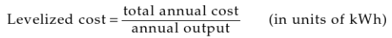
Brayton Cycle (Gas Turbine) Calculations:
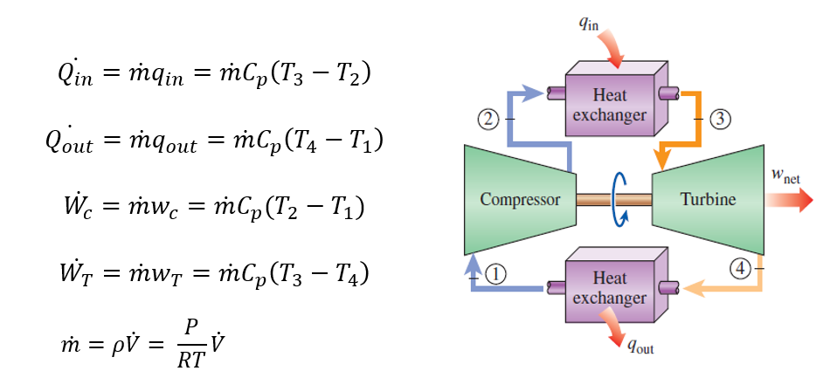
$$T_{2s}=T_{1}({\frac{P_{2}}{P_{1}})}^{\frac{k-1}{k}} T_{2a}=T_{1}+\frac{T_{2s}-T_{1}}{ζ_{c}}$$
$$T_{4s}=T_{3}({\frac{P_{4}}{P_{3}})}^{\frac{k-1}{k}} T_{4a}=T_{3}-{ζ_{T}(T}_{3}-T_{4s})$$

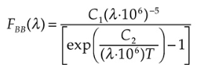
Radiation Flux at Given Wavelength, Peak radiation wavelength, and Total Radiation
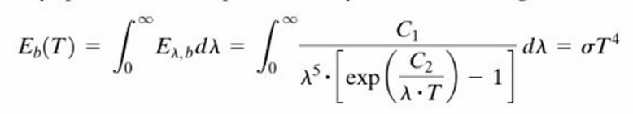

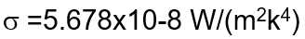
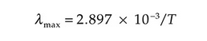

Earth Temperature in Absence of Atmospheric Greenhouse Gas Effect
